47U ENCLOSURE 19" CABINET 800X1000 FLOOR STANDING SERVER RACK - VALUCAB
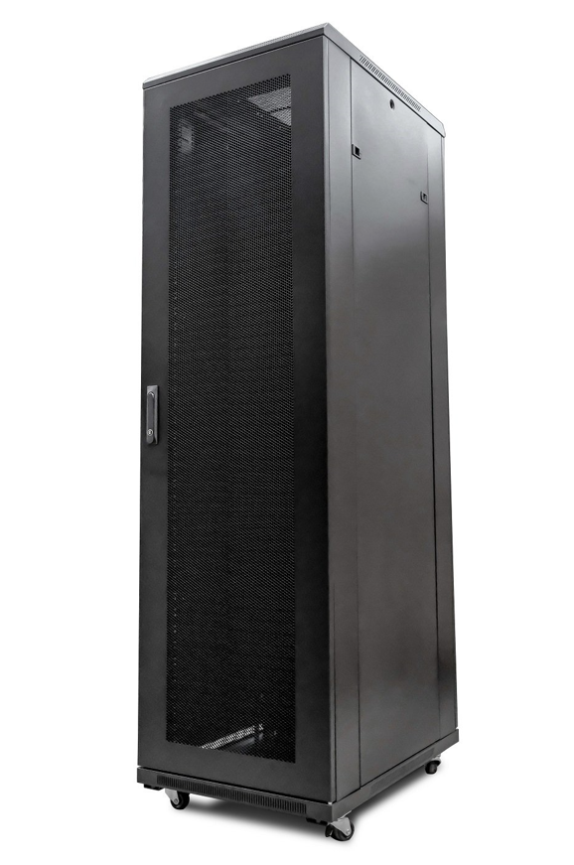

LUCAB
- P/N: CAB-FE-47U-8100NA
Available:
£881.71
Sold Out

DESCRIPTION

FEATURES
*FLAT PACK ONLY*
• 19"
• Colour : Black (Powder-coated RAL 9005)
• Dimensions: 800x1000x2320mm (inc.castors)
• Up to 800Kg static load bearing
• Front mesh high venting door (lockable)
• Left/right hinged front/rear doors
• Removable side panels for easy access
• U-numbered uprights for rack-mount product alignment
• Multiple cable entry glands for exact power and cabling entry
• Supplied with: Standard/Shipping Castors (Fitted): Set of 4 adjustable Jacking Feet (Supplied): Standard M6 Cage Nuts and Bolts (Supplied): Hex Adjusting Key (Supplied)
* NETBIT ONLY DELIVERS THESE CABINETS USING SAME DAY DELIVERY SERVICE - PLEASE CALL FOR DELIVERY QUOTE *

DOCUMENTS
Specification Sheet (PDU)

